**WireShark Task:**

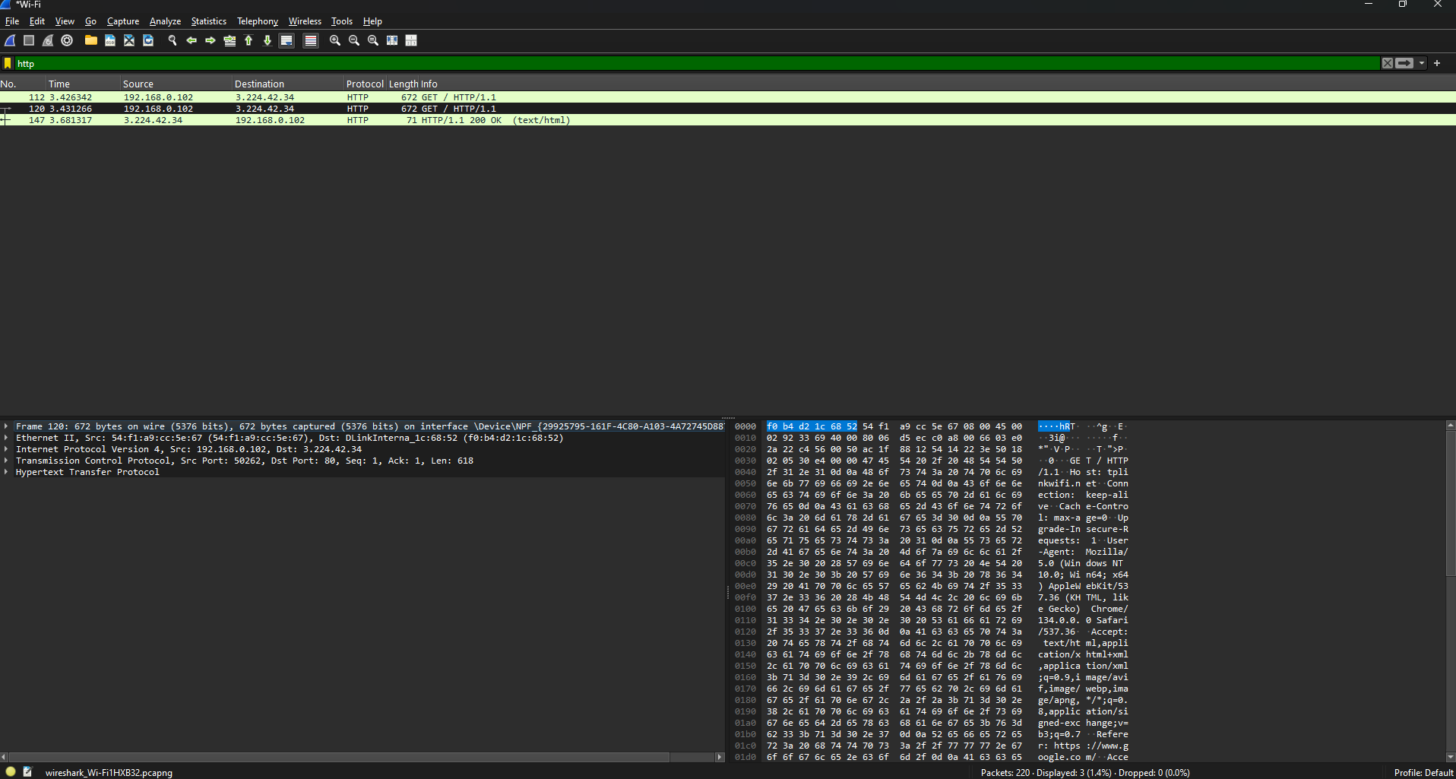

**For Request Packet:**

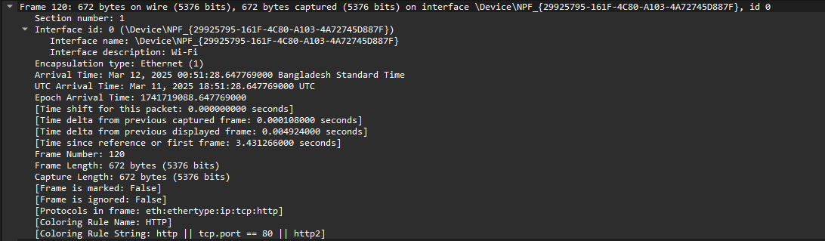

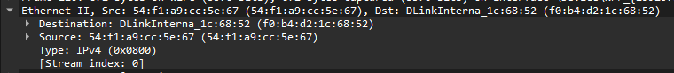

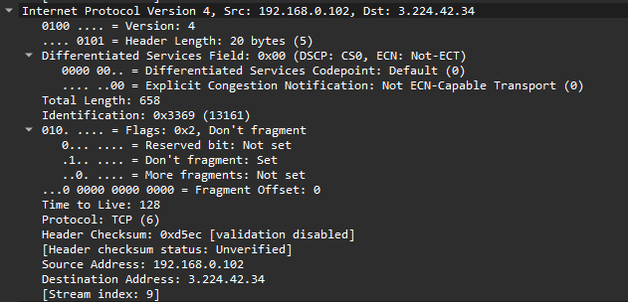

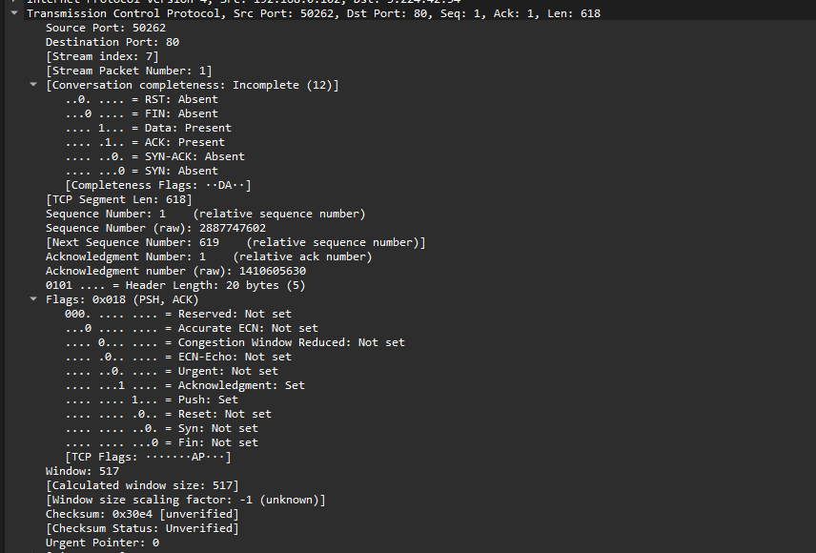

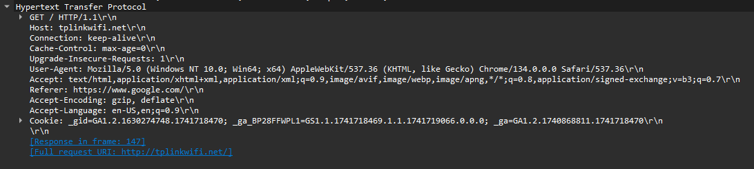

**For Response Packet:**

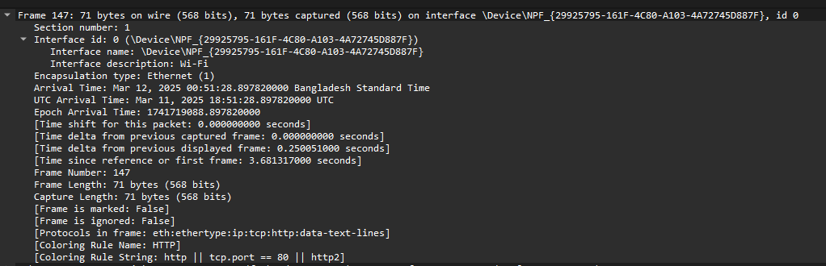

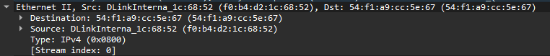

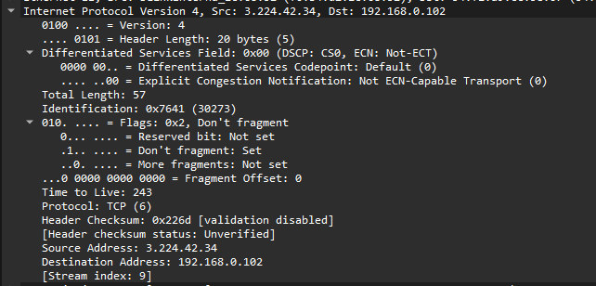

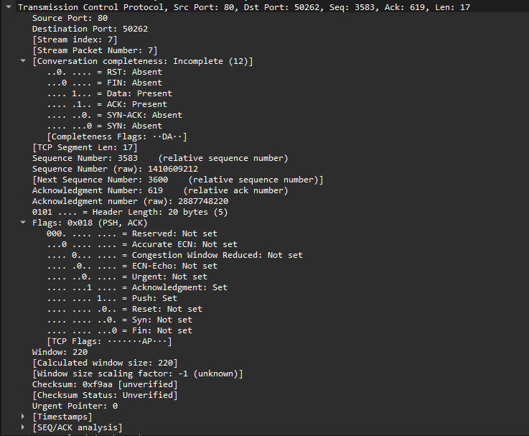

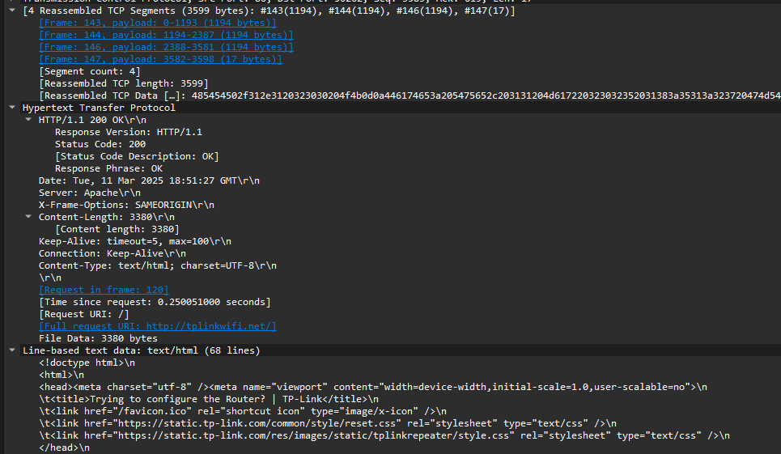

**Observation**

The client (192.168.0.102) sent an HTTP GET request to the server (3.224.42.34) at 3.431266s, requesting the root page. The server responded at 3.681317s with an HTTP 200 OK status, indicating a successful request. The response contained an HTML document, and the total delay between request and response was approximately 0.25 seconds

**Header Field Descriptions with 5-Layer Protocol Model**

In network communication, data travels through multiple layers following the 5-layer TCP/IP model:

1. **Physical Layer**  
   Deals with raw bit transmission over the physical medium (e.g., Wi-Fi, Ethernet).

The interface used for packet capture (\Device\NPF_{29925795-161F-4C80-A103-4A72745D887F}) suggests a Wi-Fi connection.

1. **Data Link Layer (Ethernet II Frame)**  
   Source MAC Address: 54:f1:a9:cc:5e:67 (Client device's MAC).

Destination MAC Address: f0:b4:d2:1c:68:52 (Router or network switch MAC).

EtherType: 0x0800 (Indicates the next layer is IPv4).

1. **Network Layer (IPv4 Header Fields)**Source IP Address: 192.168.0.102 (Client’s local IP).

Destination IP Address: 3.224.42.34 (Server IP).

Version: 4 (IPv4).

Header Length: 20 bytes.

Total Length: 658 bytes (Including headers + payload).

1. **Transport Layer (TCP Header Fields)**Source Port: 50262 (Client’s randomly assigned port).

Destination Port: 80 (Standard HTTP port).

Sequence Number: 2887747602 (Used for ordering packets).

Acknowledgment Number: 1410605630 (Confirming received data).

Flags: PSH, ACK (Push data immediately, Acknowledge receipt).

Window Size: 517 (Available buffer for receiving data).

1. **Application Layer (HTTP Header Fields)**Request Method: GET (Client requests a webpage).

Request URI: / (Root page).

Host: tplinkwifi.net (Server being accessed).

User-Agent: Mozilla/5.0 (Windows 10; Chrome 134.0.0.0) (Identifies the browser)

Accept: text/html, application/xhtml+xml, application/xml (Types of content the client can handle).

Connection: keep-alive (Requests persistent connection).

Cookies: Stores session-related data.